Activity 1:

* Do a console application that promps a user to enter a range from 1 to 9.
* If a user skips any number between 1 and 9 the application should display the following.

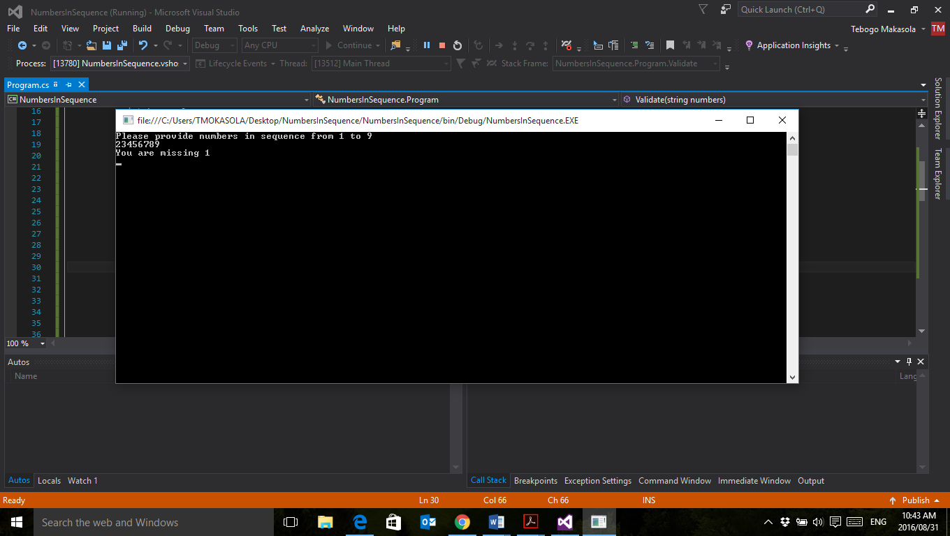

If a user enters a full range it should display the following.

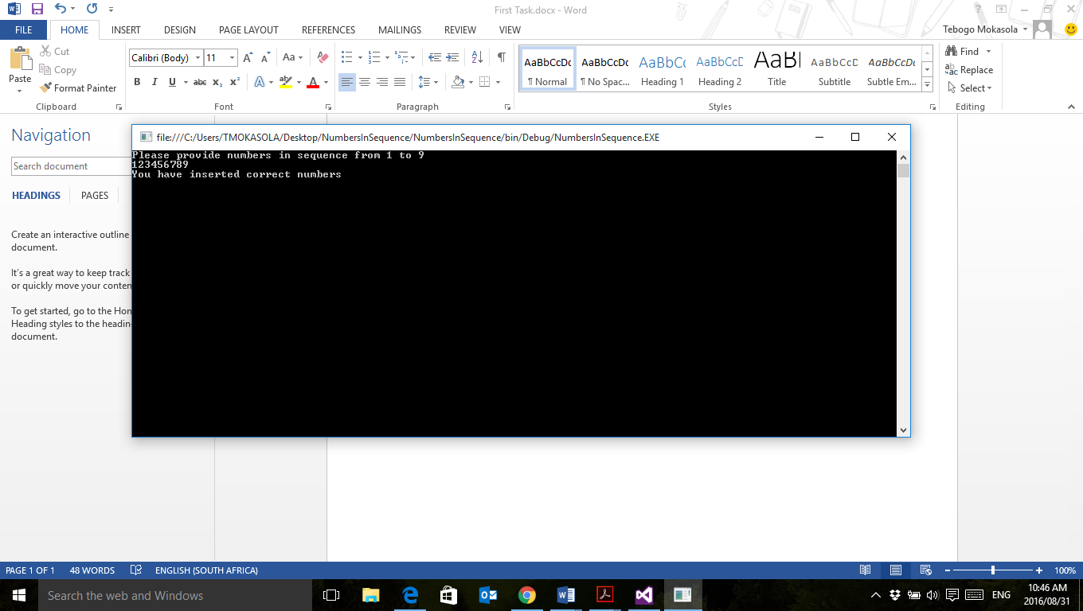

After the user enters the numbers the application should ask if the user wants to enter again or exit.

